

* Begin by selecting Edit Dashboard in the far right corner



* Optionally you may edit the name of your dashboard to fit your style and personality.

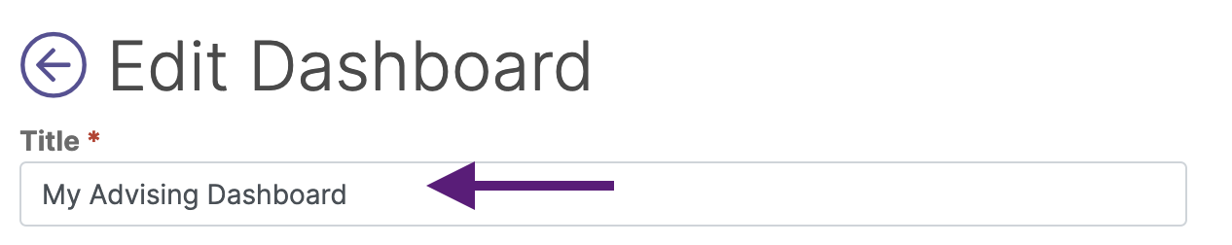

* Select the Layout pencil icon to adjust your layout
* Select the layout of your choice and then select OK to save the layout to your dashboard

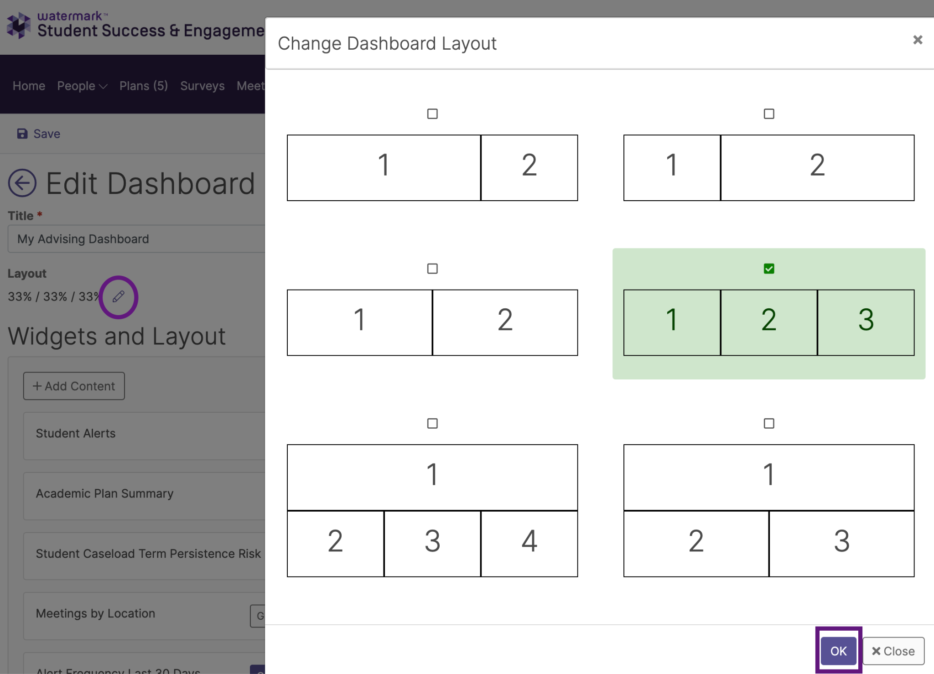

* To add widgets - Select + Add Content
* To remove widgets - Select the trash can of the widget you wish to remove
* Widgets may be added back at any time

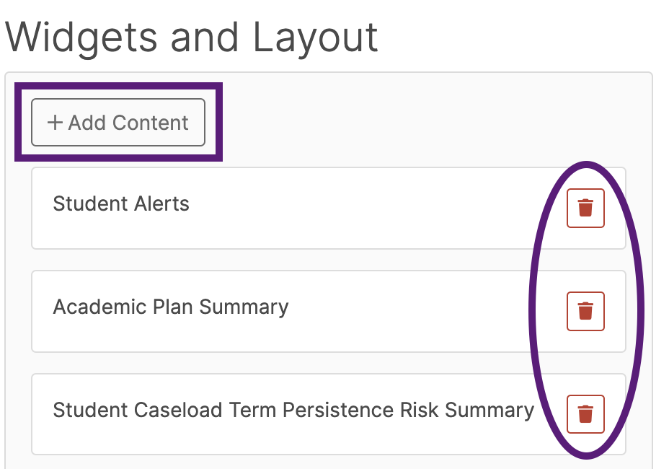

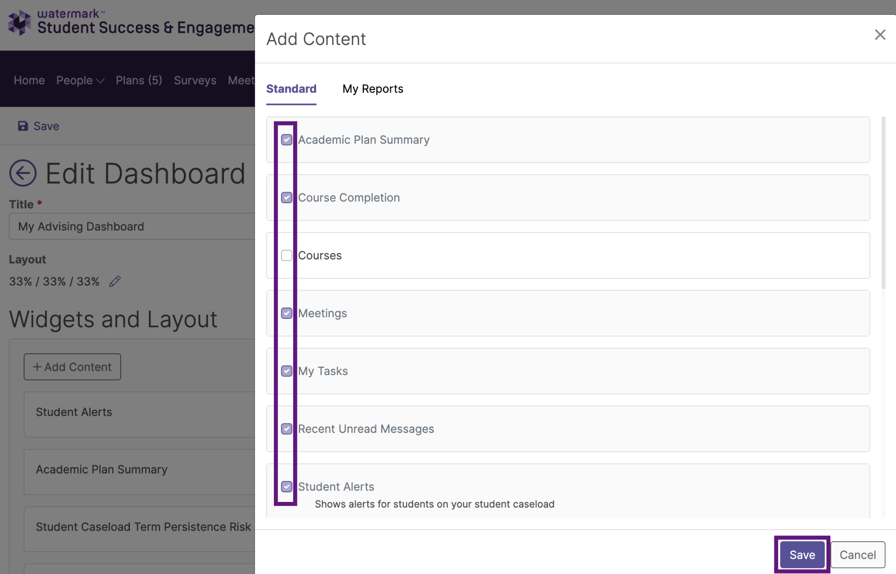

* To move widgets - Select the widget, then drag and drop to the desired location
* Save changes and return to Home to view your customized Dashboard

\*Everything on the homescreen is all based on permissions\*